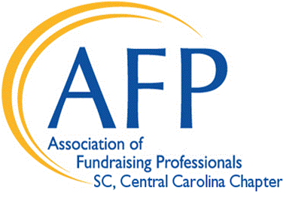

2017 Sponsorship Opportunities

October 26, 2017
The Columbia Marriott
1200 Hampton Street, Columbia, SC 29201

11:30 a.m. – 1 p.m.
Program: Noon – 1 p.m.

Your generous sponsorship ensures that National Philanthropy Day sustains the tradition of excellence and highlights our community’s appreciation for our volunteers and donors.
National Philanthropy Day is the perfect opportunity for you to publicly recognize people who help your organization.

$2,500 Presenting Sponsor
2 Tables of eight Premier table locations
Recognition on all marketing materials, website and podium signage day of event
Logo on program listing and signage

$1,000 Gold Level Sponsor
Table of eight Premier table location
Recognition on website and podium day of event
Logo on program listing and signage

$500 Silver Level Sponsor
Table of eight
Mid-room table location
Name on program listing and signage

$500 Exhibiting Sponsorship
Premier Exhibitor location
Distribution of marketing materials at each guest table
Two guests passes to the NPD luncheon
Recognition on website and podium day of event
Logo on program listing and signage

Printing deadline is September 29, 2017. Please submit your logo by email in JPEG or GIF format on or before the deadline to jwallace@uway.org. For more information about sponsorships, please contact Louis Fawcett at LFawcett@edventure.org.

Please complete the following information and return it to the address shown below. You may also fill out a sponsorship form online at afpcsc.net.
Company Name:

Your Name:

Address:

Telephone Number: Email:

Key Executive:

Sponsorship Level

Please accept this document as an official commitment for our organization to be a level sponsor at the 27th Annual National Philanthropy Day luncheon hosted by the Association of Fundraising Professionals, SC Central Carolina Chapter.

Additional Tickets: I would like to purchase tickets at $42.00 each Signed and Agreed:
Signature:

Print Name & Title:

Mail completed form with payment to:

Association of Fundraising Professionals
SC Central Carolina Chapter
P. O. Box 7701 Columbia, SC 29202

